********

**TPN and Steppin’ Up sponsors receive tremendous exposure to a community passionate about eliminating personal violence, all while making a transformative impact on the lives of survivors!**

**If you are interested in becoming a sponsor, please fill out the form on the reverse side and return it to TPN. You may also call 603-543-0155 and ask for Jennifer Ucci, Development Director, or email** [**jenn@turningpointsnetwork.org**](mailto:jenn@turningpointsnetwork.org)

**You may also sign up at our website**

[**www.turningpointsnetwork.org/steppin-up**](http://www.turningpointsnetwork.org/steppin-up)

**Gold Sponsor: $1,000**

* Company logo linked on TPN’s website to your company website.
* Media promotions/spotlight:

e-blasts/monthly social media posts with link to company website. (Facebook, Twitter, Instagram.)

* One company listing on Day of Event Signage
* Banner hung at 5k event (to be provided by the sponsor.)
* Company name will receive Gold billing in Program.
* 2 Free T Shirts for your company team.

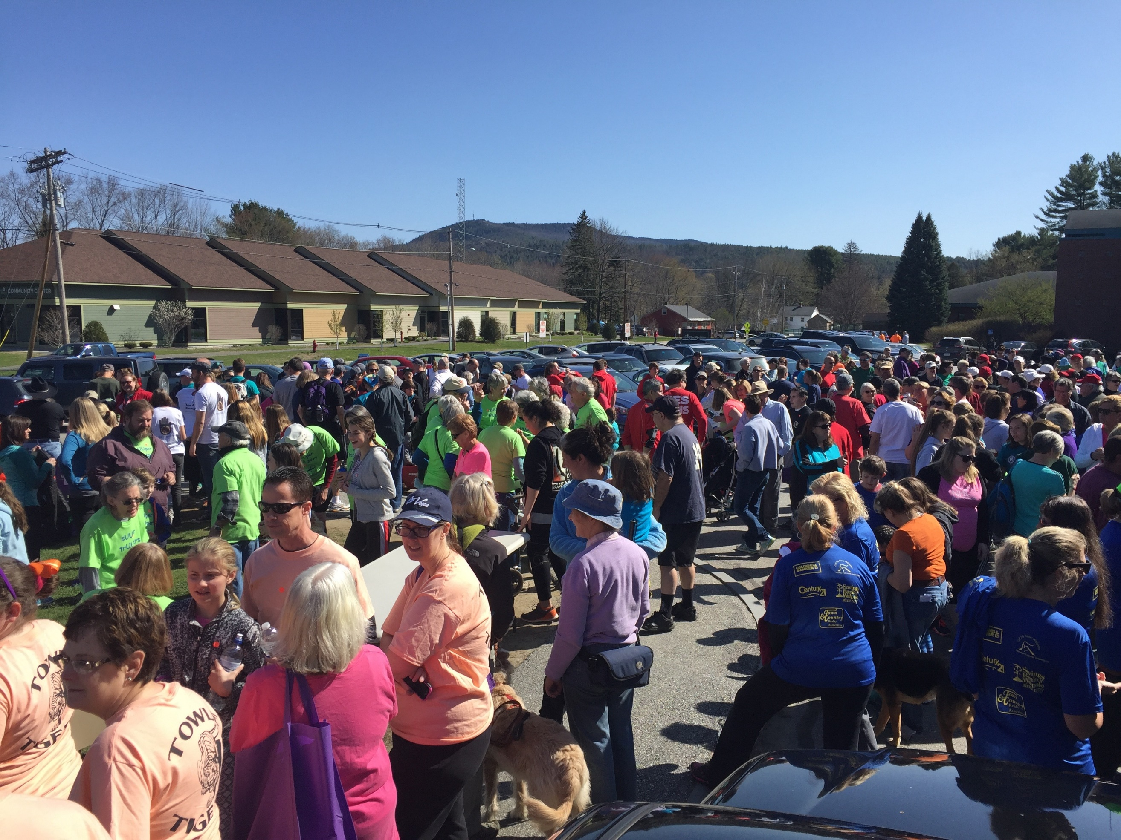

**Food Sponsorship: $750**

* Company logo linked on TPN’s website to your company website.
* Media promotions/spotlight in e-blasts/monthly social media posts with link to company website. (Facebook, Twitter, Instagram.)
* Special Recognition as a Food Sponsor
* Exclusive Food Court Signage
* Logo in all Print Media
* Top Billing in Program as Food Sponsor

**Sapphire Sponsor: $500**

* Company logo linked on TPN’s website to your company website.
* Media promotions (Facebook, Twitter, Instagram.)
* One company listing on Day of Event Signage
* Company name will receive Sapphire billing in Program.

**Silver Sponsor: $250**

* Company logo linked on TPN’s website to your company website.
* Recognition on Facebook
* Company name will receive Silver billing in Program.

**Diamond Sponsor: $2,500**

* Company logo linked on TPN’s website to your company website.
* Monthly media promotions/spotlight: e-blasts/monthly social media posts with link to company website. (Facebook, Twitter, Instagram.)
* Company mentioned in radio promotions.
* Table space at 5k event.
* Two company listings on Day of Event Signage
* Banner hung at 5k event (to be provided by the sponsor.)
* Company name will receive top billing in Program.
* Special recognition at Event Rally.
* Thank-you signage on 5k course highlighting company.
* Company name on 200 Designer Giveaways.
* 10 Free T Shirts for your company team.

**Platinum Sponsor: $1,500**

* Company logo linked on TPN’s website to your company website.
* Monthly media promotions/spotlight: e-blasts/monthly social media posts with link to company website. (Facebook, Twitter, Instagram.)
* Table space at 5k event.
* Two company listings on Day of Event Signage
* Banner hung at 5k event (to be provided by the sponsor.)
* Company name will receive Leadership billing in Program.
* Thank-you signage on 5k course highlighting company.
* Company name on 100 Designer Giveaways.
* 4 Free T Shirts for your company team.