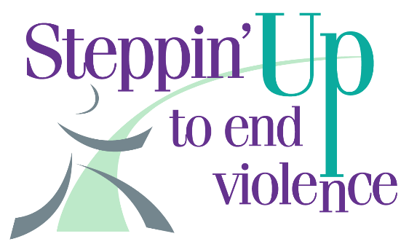
We’re back and getting ready to rally, walk, run, roll or stroll in person again!
Steppin’ Up 2022 Saturday, April 30th at 10:00 AM, Claremont Middle School

February, 2022
Dear Team Leaders,
Each day Turning Points Network (TPN) lives out our mission of “Preventing Violence, Promoting Respect, Strengthening Lives.” For more than 40 years, TPN has been Sullivan County’s crisis and support center for those impacted by domestic violence, sexual abuse, stalking and sex trafficking.
Whether meeting a victim/survivor of domestic violence at court, providing emergency shelter to a family fleeing abuse, offering support and resources for a parent whose child has been sexually abused or teaching healthy relationships skills to students from elementary school through high school, TPN is the only agency of its kind providing these services in Sullivan County.
Our services are tailored to meet individual needs and we never want cost to be a barrier for someone seeking help or for a school wanting to implement violence prevention programming. Here's where you come in!
When you fundraise for Steppin’ Up To End Violence, you directly support the victims/survivors we work with and the youth we educate. Your fundraising has the power to help create safer homes, communities, and schools. That is an investment in our collective future!
We have continued to provide 24/7 services, at no cost to all who need them, throughout this pandemic and we need your help to make Steppin’ Up 2022 a success.
We know these continue to be tough times for many. Some of your teammates will be able to fundraise and some will not. You can be confident in knowing that we are diligent stewards of every dollar donated. Whatever fundraising you and your team can do will provide direct support to your community: possibly your neighbors, co-workers, friends, family.
Teams put the “fun” in the fundraiser with their energy, creative team names, t-shirts and shared commitment to helping TPN. Steppin’ Up is a powerful community event because of the teams and individuals who collectively raise their voices and funds to help those who have often felt voiceless.
We have online resources to support you and are here to answer questions. Don’t hesitate to reach out: email kerry@turningpoitnsnetwork.org, call 603-543-0155 or visit our website at turningpointsnetwork.org/steppin-up.
Thank you for wanting to help keep our life-changing services free and available to anyone who needs them. We couldn’t do this work without the support from our community.
Sincerely,
Kerry Rochford Hague, on behalf of the Teams Sub-Committee
Turning Points Network is a charitable organization under Section 501(C)(3) of the IRS code. EIN: 02-0350899

